# Lab 12

**1. Creating a Disk Image Backup**

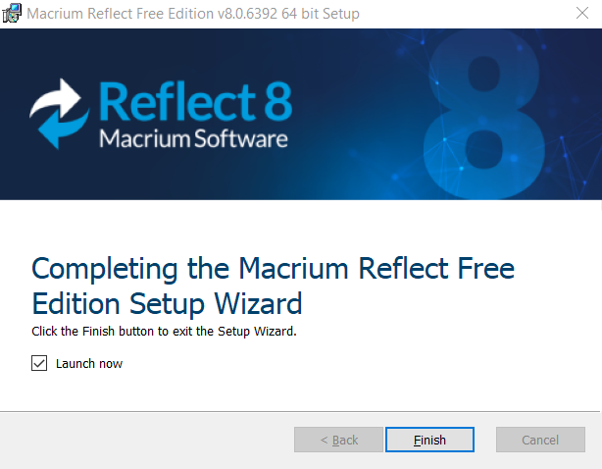

Figure 1 Macrium Reflect Installer

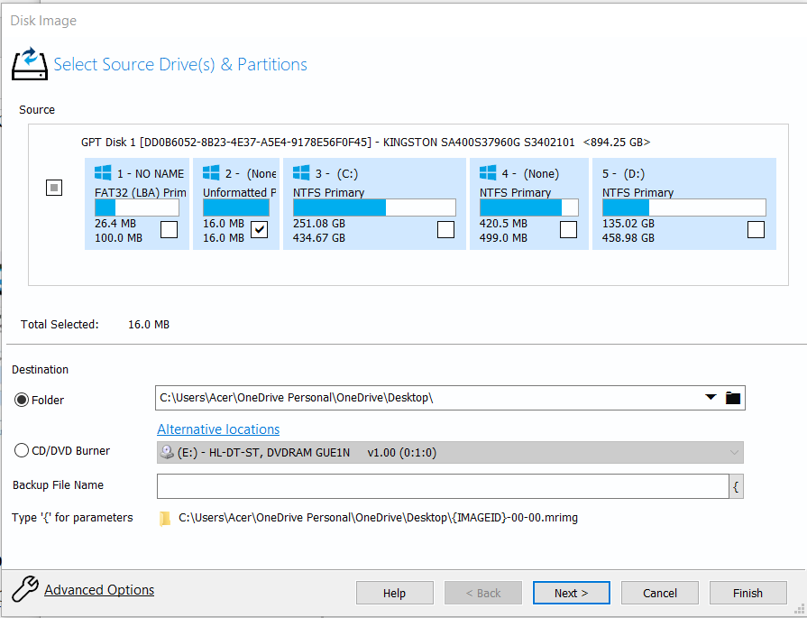

Figure 2 Macrium Reflect Disk Image

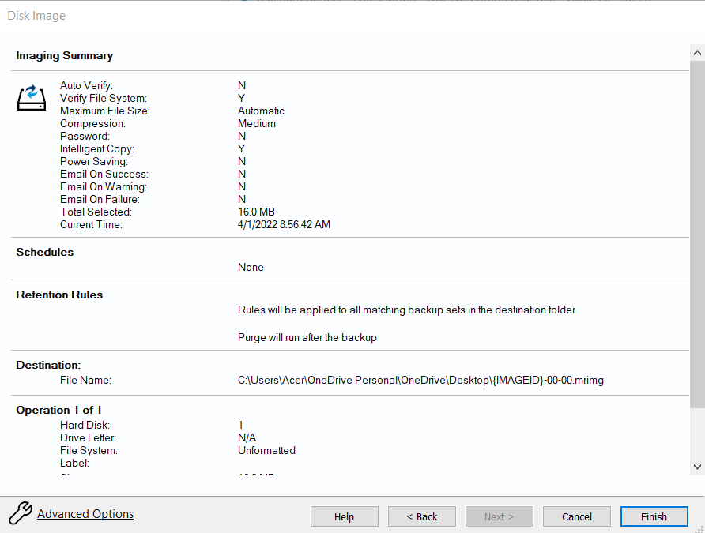

Figure 3 Macrium Reflect Image Summary

1.1 Differentiate Full, Differential and Incremental retention rules.

Full Backup: Stores all information present

Differential Backup: Stores only the difference between last full backup and the current state of data

Incremental Backup: Stores the difference between the current state of data and state of data from previous successful backup

1.2 Differentiate between disk cloning and disk imaging. What is the advantages of disk imaging?

Disk Cloning: Creates an exact functional one-to-one copy of hard drive

Disk Imaging: Creates an compressed archive of hard drive

Advantages of disk imaging: Multiple disk images can be stored on other storage than hard drives such as optical media and flash drive

**3. Entering and Viewing Metadata**

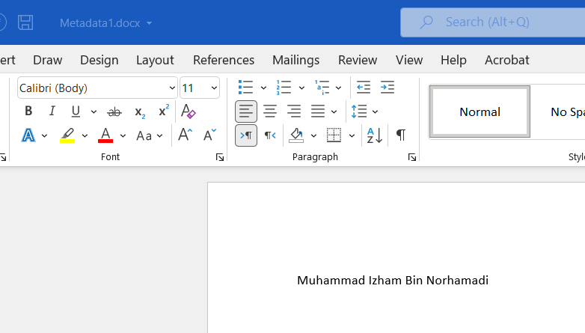

Figure 4 Metadata1.docx

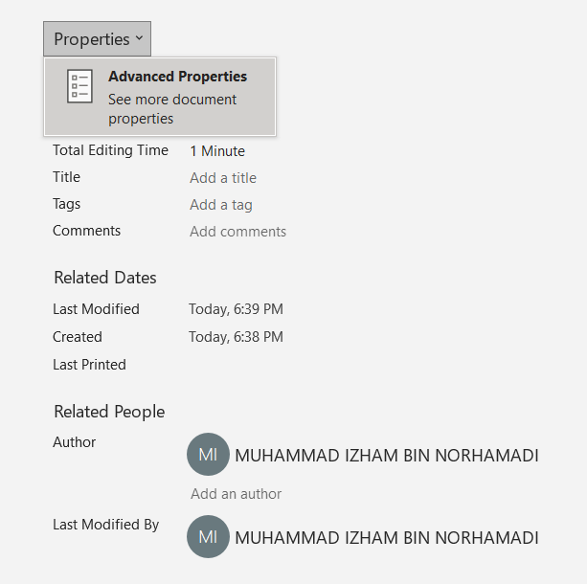

Figure 5 Microsoft Word Advanced Properties

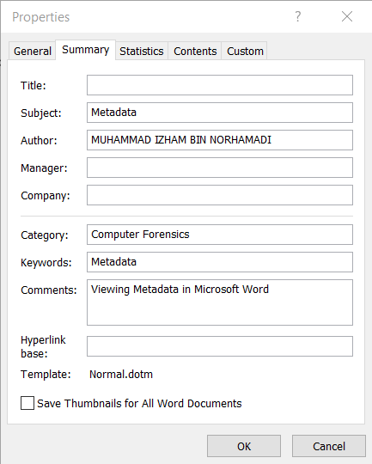

Figure 6 Property Fields

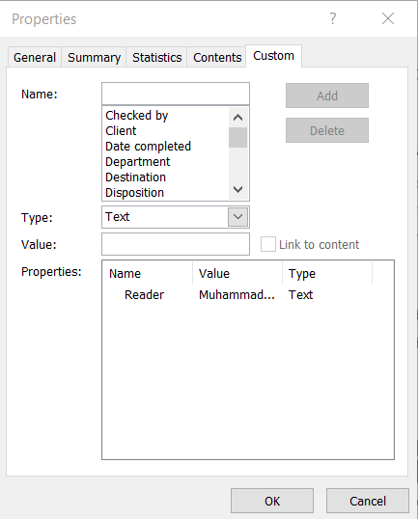

Figure 7 Custom Properties

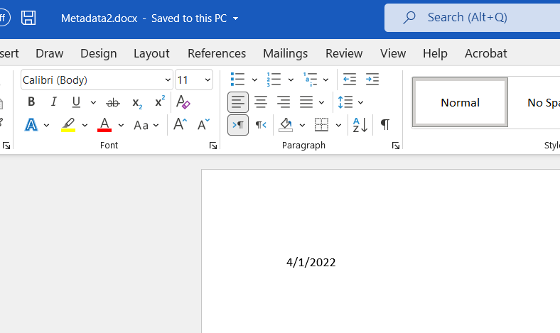

Figure 8 Metadata2.docx

3.1. How could a computer forensics specialist use this metadata when examining this file?

* Metadata can be used by forensics specialist to understand the history of an electronic file such as when it was created, modified, and accessed

3.2 What properties carried over to Metadata2.docx from Metadata1.docx, even though the contents of the file were erased? Why did this happen? Could a computer forensics specialist use this technique to examine metadata, even if the contents of the document were erased?

* Metadata field such as subject, author name, and keywords. Metadata persists so that finding and working with a particular files easier. Yes, the forensics specialists can use this method of examining metadata

**4. Viewing and Changing the Backup Archive Bit**

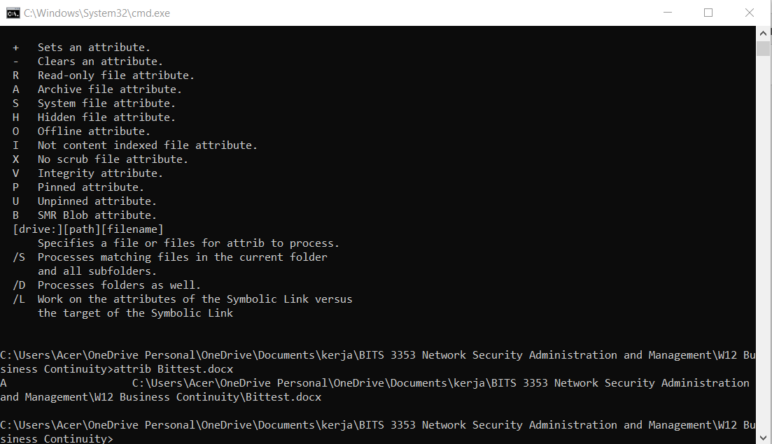

Figure 9 A Attribute Bittest.docx

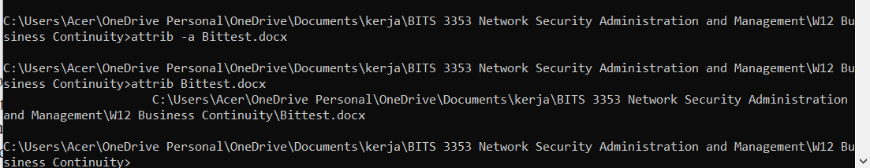

Figure 10 Attribute Bittest.docx removed